UNIVERSITY OF GHANA
DEPARTMENT OF STATISTICS AND ACTUARIAL SCIENCE
ASTAA 607_COMPUTATIONAL STATISTICS 1
ID22424240
1a)
### Q1.a). Describing the crabs dataset
?crabs

Output:
a. Describe the dataset using the one in package MASS.
> library(MASS)
> # Question 1
> # a. Describe the dataset using the one in package MASS.
> library(MASS)
Description
The crabs data frame has 200 rows and 8 columns, describing 5 morphological measurements on 50 crabs each of two colour forms and both sexes, of the species Leptograpsus variegatus collected at Fremantle, W. Australia.
Usage
crabs
Format
This data frame contains the following columns:
sp
species - "B" or "O" for blue or orange.
sex
as it says.
index
index 1:50 within each of the four groups.
FL
frontal lobe size (mm).
RW
rear width (mm).
CL
carapace length (mm).
CW
carapace width (mm).
BD
body depth (mm).
Source
1b)
### ### Q1. b. Load the dataset and display its structure
data("b)

Output:
### Q1. b)

str(crabs) # For checking the structure of the dataset2 ### Q1. b) Displaying the stricture of the dataset# b. Load the dataset and display its structure
> data("crabs")
> # b. Load the dataset and display its structure
> data("crabs")
> data(crabs) ## To laod the dataset, optional for crabs since crabs is already available in our R environment.
> ### Q1. b) Displaying the stricture of the dataset

1c)

### Q1 c). # c. Produce the frequency table for species and sex
table(crabs$sp, crabs$sex)

setosa versicolor virginica
50 50 50

# c. Produce the frequency table for species and sex
> table(crabs$sp, crabs$sex)

F M
B 50 50
O 50 50

### Q1
d. Construct an appropriate bar chart or mosaic plot summarising the group composition.
barplot(table(crabs crabs$sex),
beside = TRUE,
col = c("lightblue", "pink"),
legend = TRUE,
xlab = "Species",
ylab = "Frequency",
main = "Species and Sex Distribution")

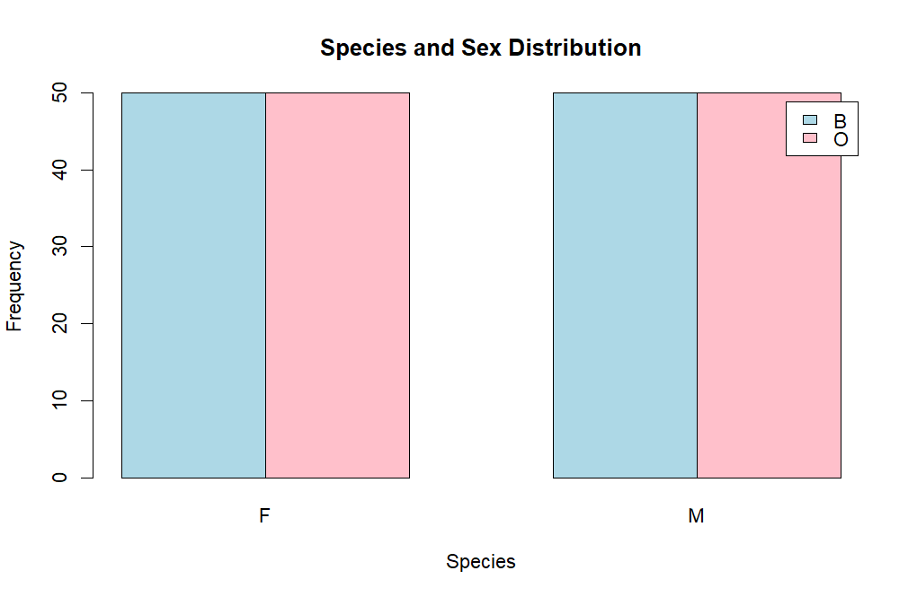
Comment on whether the dataset is balanced across the four groups
# Yes — the dataset is perfectly balanced. 50 observations in each of the four groups
# Equal numbers across both species
# e. Comment on whether the dataset is balanced across the four groups
# Yes — the dataset is perfectly balanced. 50 observations in each of the four groups
# Equal numbers across both species
# Equal numbers across both sexes
"setosa"])

# Yes — the dataset is perfectly balanced. 50 observations in each of the four groups
# Equal numbers across both species

1e# Question 2 - Distribution of Body Depth
# a. Construct side-by-side boxplots of body depth (BD) for the four groups defined by species and sex
group <- interaction(crabs$sp, crabs$sex))

Output: # Question 2 - Distribution of Body Depth
> # a. Construct side-by-side boxplots of body depth (BD) for the four groups defined by species and sex
> group <- interaction(crabs$sp, crabs$sex)

2b)
### Q1. # b. Identify any outliers and compare the central tendency and variability between groups
by(crabs$BD, group, boxplot.stats) # there are no outliers

Output:

1)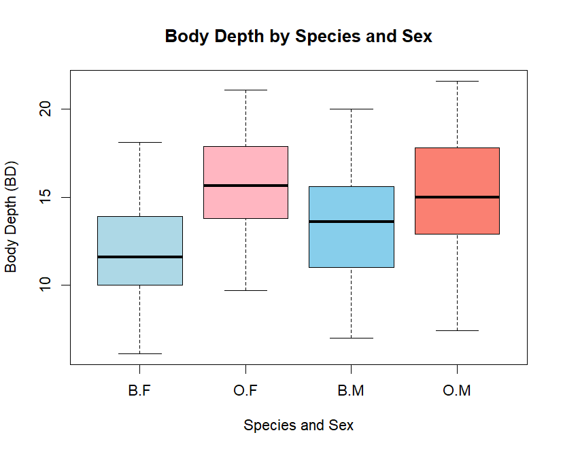
### Q3 Question 3 - Carapace Length Distribution by Species
# a. Produce hsitograms of carapace length (CL) for each species
# Set plotting area to 1 row, 2 columns
par(mfrow = c(1, 2))

Output:

1b) Question 3 - Carapace Length Distribution by Species
> # a. Produce hsitograms of carapace length (CL) for each species
> # Set plotting area to 1 row, 2 columns
> par(mfrow = c(1, 2))

Outp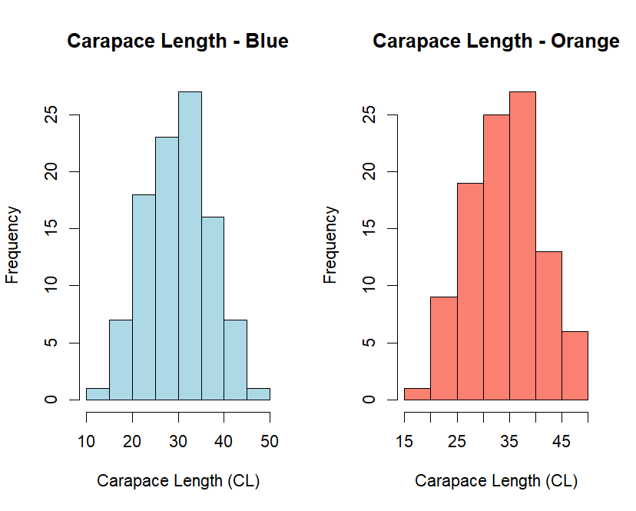ut:
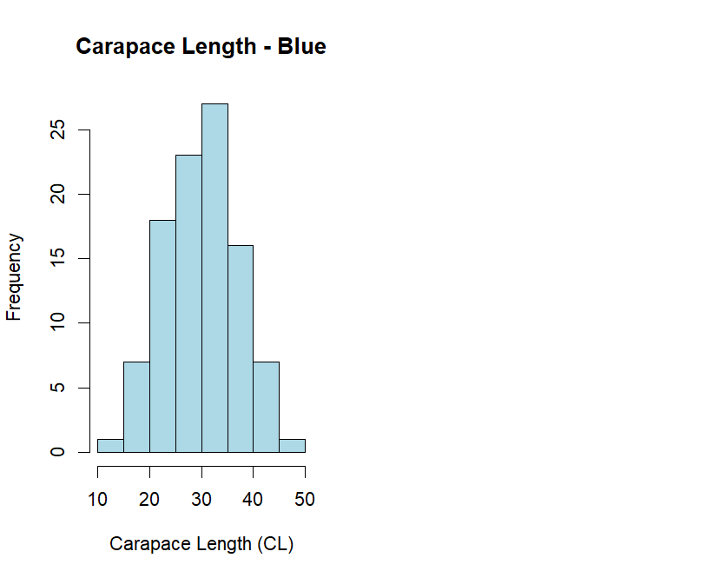
3b)
###
# Orange species
hist(crabs$CL[crabs$sp == "O"],
col = "salmon",
main = "Carapace Length - Orange",
xlab = "Carapace Length (CL)",
breaks = 10)

Output:

3b)

Output:

1b)
b. Describe and compate the shapes of the distributions, commenting on skewness and modality

# - Shape and Modality
# Both species show approximately unimodal distributions.
# The histograms are fairly smooth without multiple distinct peaks.
# This suggests one main population per species

# - Skewness

Output:

3b)

Question 4. - Comparison of Mean Measurements
# a. Compute the mean of each morphological measurements (FL, RW, CL, CW, BD) by species and sex
means <- aggregate(cbind(FL, RW, CL, CW, BD) ~ sp + sex,
data = crabs,
FUN = mean)

Output:

)
# Question 4. - Comparison of Mean Measurements
> # a. Compute the mean of each morphological measurements (FL, RW, CL, CW, BD) by species and sex
> means <- aggregate(cbind(FL, RW, CL, CW, BD) ~ sp + sex,
+ data = crabs,
+ FUN = mean)

Output:

4b)
# b. Construct a grouped bar chart to display these means
# converting to matrix form (remove grouping columns)
mean_matrix <- as.matrix(means[, 3:7])

Output: b. Construct a grouped bar chart to display these means FUN = mean)
> # b. Construct a grouped bar chart to display these means
> # converting to matrix form (remove grouping columns)
> mean_matrix <- as.matrix(means[, 3:7])
> # converting to matrix form (remove grouping columns)
> mean_matrix <- as.matrix(means[, 3:7])

4b)
# Grouped bar chart
barplot(t(mean_matrix),
beside = TRUE,
col = c("lightblue","pink","lightgreen","orange"),
legend = rownames(mean_matrix),
xlab = "Morphological Measurement",
ylab = "Mean Value",
main = "Mean Morphological Measurements by Species and Sex")

Output:

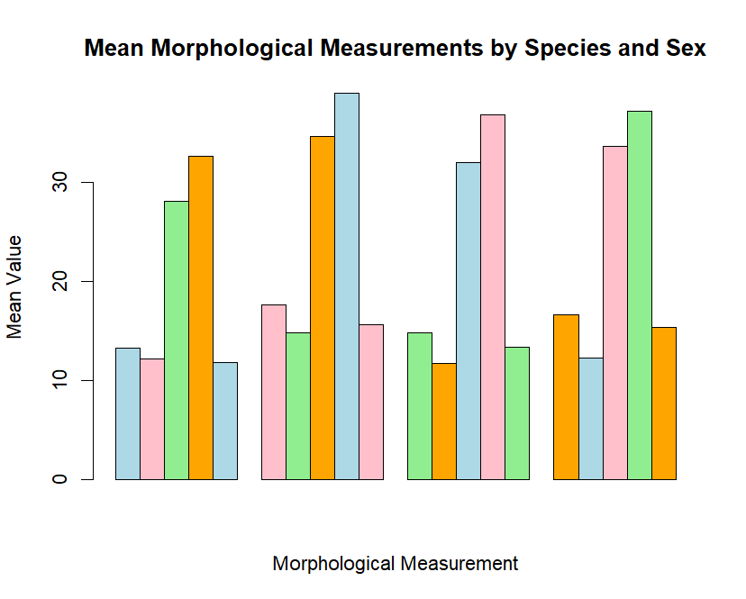

5a. Produce a scatterplot matrix (pair plot) of five measurements

pairs(crabs[, c("FL", "RW", "CL", "CW", "BD")],
main = "Scatterplot Matrix of Crab Measurements",
col = as.numeric(interaction(crabs$sp, crabs$sex)))

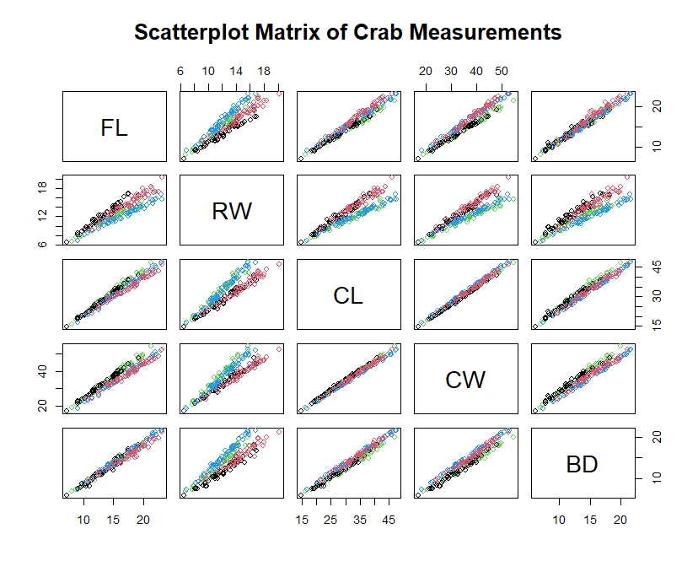

b. Describe the strength and nature of the relationships among variables
# - Strength of Relationships
# All five measurements are strongly positively correlated.
# Larger crabs tend to be larger in all dimensions.
# This indicates strong overall body size dependence.

# - Nature of Relationships
# Relationships appear approximately linear.
# No obvious curvature or nonlinear patterns.
# No clear clustering beyond group differences.

# - Strongest Associations
# The strongest relationships are typically between:
# Carapace Length (CL) and Carapace Width (CW)
# Rear Width (RW) and Carapace Width (CW)
# These measure closely related aspects of overall shell size.

The variables largely measure overall body size, so:
> # They contain substantial redundant information.
> median_setosa_sepal_length <- median(iris$Sepal.Length[iris$Species == "setosa"])
> median_setosa_sepal_length
[1] 5
> mode_setosa_sepal_length <- iris$Sepal.Length[which.max(table(iris$Sepal.Length[iris$Species == "setosa"]))]

>

